Answer 10
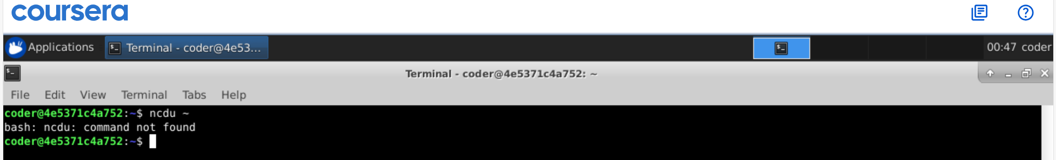
Explanation: we don’t have permission for ncdu command. But it’s a interactive tool used to navigate through directory and files. We can delete files and do more just with different options.
Nandita mam explained it in class I will attach the screenshot from the class which will show hoe the interactive tool look like.
